[content from University of Virginia , google & google images]
Today’s Lecture Road Map
Dated:
- From where it all started
  - Evolution of devices –> Operating Systems -> Architectural similarity / Development decision

- Mobile Application development
- Development challenges and models
- Model View Controller (Reading)
- Conceptual Understanding:
  - Cloud Computing: Cloud computing is on-demand access, via the internet, to computing resources—applications, servers (physical servers and virtual servers), data storage, development tools, networking capabilities, and more—hosted at a remote data center managed by a cloud services provider (or CSP).
  - Mobile Computing: It is a technical field that covers the design, development and evaluation of mobile applications using appropriate solutions that meet user requirements. This includes learning the technology that is used to perform a wide variety of tasks on devices that are portable.
  - Ubiquitous Computing: Ubiquitous computing (or "ubicomp") is a concept in software engineering, hardware engineering and computer science where computing is made to appear anytime and everywhere. In contrast to desktop computing, ubiquitous computing can occur using any device, in any location, and in any format. Another term used with ubiquitous computing is pervasive but the main goal of pervasive computing is to create an environment where the connectivity of devices is embedded in such a way that the connectivity is unobtrusive and always available.
  - Context Aware Apps (for Sensors and Sensor Ethics)
-------------------------------------------------------------------------------------------------------------------------------
- First Mobile Phone [1983] : The Motorola DynaTAC 8000X (13 x 1.75 x 3.5, 2.5 pounds, $3,995)
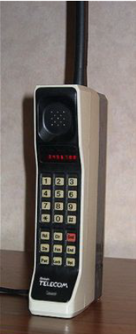

- First Iphone in 2007
- First Android in 2008
How Size is Reduced? Batteries (lithium Ion) got better (Technologies improved and evolved), form factors improved.
Form Factor of a mobile phone is its size, shape, and style as well as the layout and position of its major components. Mathematically it’s a factor which compensates for irregularity in the shape of an object, usually the ratio between its volume and that of a regular object of the same breadth and height. [copied content google.com]

- The handset manufacturers didn’t want to write all the applications for these new phones, and they didn’t want to open up their platform hence the first mobile web platform was introduced

WAP: wireless application protocol
WML: Wireless Markup Language
------------------------------------------------------------------------------------------------------------------------------
A stripped-down HTTP that meant to transmit over the unreliable mobile network WAP used WML instead of HTML – used a ‘card’ mentality.

- Mobile Phone Economies were made through SMS when there were no App stores Money to be made!
- Handheld devices were selling like gangbusters The Internet was full of images and media that people wanted to consume on the go.

- Bigger Players got involved: Nokia had a large portion of the mobile phone market earlier others like Blackberry, Samsung, HTC, etc
- Each had (basically) their own OS which made third-party (APP) development tricky
What changed with phones? Phones started running known operating systems (Windows CE and Linux)

- Microsoft tried to influence “write once, run on any Windows device”. It worked for a while with PDAs, but never really caught on with phones

- Apple started off as a phone that had a web browser and iPod bolted on and evolved into much more once the App Store opened

- Google just provided the OS and let others build the devices (for a while). It is Open-source OS + no developer fees = lots of interest and apps
MARKET FRACTURED
although
The design philosophy is same for Android and iOS
(Same three tier design philosophy)
BASE OS IS LINUX

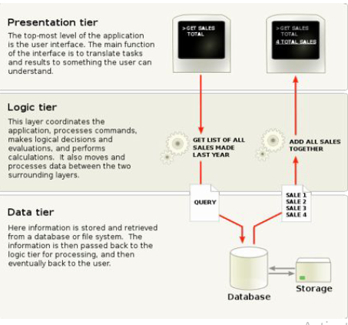
MVC
Model: Database (server) SQL lite
View: UI/UX (XML files)
Controller: Code (Android: Activities) (iOS: ViewController)

+ Keep the presentation separate so it's lightweight, easier to maintain, and can be tested separately
+ Keep the logic separate so you can change the logic as needed without having to change the presentation too much
+ Keep the data separate because you should NEVER build a system based on the current data values

- User sees the view
- User is using the controller (via view)
- Controller manipulate model
- Model update the view
- User sees the view
MOBILE APPS VS DESKTOP APPS -> use of CLOUD
Client / Server (APP is using cloud services)
- Thick Client (mostly local)
- Thin Client (mostly on server)
Thick Client
- Business and some data services on the phone itself
- Good for apps that have to run “off the grid”
Thin Client
- Most business and all data services on the server
- Good for apps that require phone services, but does require Internet connectivity

- What will happen to your app when you get a call?
- THINK THICK VS THIN CLIENT!!!!!

